Proposal Report of CP on Nepal Handicraft Online Market



Submitted by: Submitted to:

Lizan Bajracharya Sir Sudeep Bajimaya

Batch- 22A

L5DC

NCC ID: 00174404

Contents

Table of figure 3

Introduction 4

1.1. Project Introduction 4

1.2. Justification of the project 4

1.3. Features of the project 4

1.4. Overview of the project 4

Chapter 2: Scope of Project 5

2.1. Scope: 5

2.2. Limitation: 5

2.3. Aim: 5

2.4. Objectives: 5

2.5. Overview of the scope: 5

Chapter 3: Development Methodology 6

3.1. Description of Methodology: 6

3.2. Design Pattern: 7

3.3. Architecture: 9

Chapter 4: Project Planning: 11

4.1. WBS: 11

4.2. Milestone: 13

4.3. Gantt Chart: 14

Chapter 5: Risk Management 15

Chapter 6: Configuration Management 17

Conclusion 18

References and Bibliography 19

# Table of figure

Figure 1: Waterfall Model 7

Figure 2: MVC pattern 8

Figure 3: Three-tier architecture 10

Figure 4: WBS figure 1 11

Figure 5: Project Schedule 14

Figure 6: Gantt Chart 14

Figure 7: Directory Structure for Project 17

# Introduction

## Project Introduction

***Nepal Handicraft Online Market*** contains the information regarding the various handicraft product that are produce in the country covering the small-scale handicraft product to larger scale. Since, there are various product present this system also boost as a market for those products so that people can buy those products through this which will boost the economy of the seller. This project is fully web based for easy access by all. The main problem that can be faced in this system is people will find it hard to verify whether the product is genuine or not. People will also find the problem in the product as smuggled good or not. The system I am trying to make is to boost the handicraft product present in out country so that the sales rate of those product can be better.

## Justification of the project

In Nepal different handicraft product are produce which don’t get enough market to sell it. Though they are made, people find it very difficult to sell them as there is lack of market. I choose this project to increase the market of handicraft product that are made in the country. This project focus on online market so that the goods can be sold easily.

## Features of the project

The main features of the project include:

1. Online Transaction
2. Categories based on handicraft products
3. Product Info
4. Dealer Information
5. Login system
6. Bill generation

## Overview of the project

This project is based on the availability of a market for the handicraft product to boost the economy of the people allowing involvement of many people who are lacking on job as well as smooth sales of the product between customer. This project contains various facility for the benefits of the users and customers.

# Chapter 2: Scope of Project

## 2.1. Scope:

This project main scope deals with the e-commerce of the handicraft product that are found in Nepal. This project makes the product distribution of handicraft that are made easier available to people.

## 2.2. Limitation:

This project contains few limitations that have to be tackle for smooth system. Some of those limitation includes:

1. Difficult to verify the product
2. Shipping charge will be heavy
3. Limited to single country only

## 2.3. Aim:

Every project has different aim that it fulfills. This project also has its own aim which is given below:

1. Boost of the handicraft product present in the country
2. Making an online market for the product so that the good can be sold without any problem
3. Increasing job opportunity by creating an online market which allow any scale of handicraft product to be displayed and sold.

## 2.4. Objectives:

To fulfill the aim of this project I have to follow various objectives which includes the following:

1. To provide smooth transaction of the product with the customer
2. To provide market that will enable people to place their order and know about the products
3. To increase the market of handicraft product throughout the country
4. To make people know about the various handicraft product that are found in the country.

## 2.5. Overview of the scope:

This project mainly acts as a market that deals with the various handicraft product that are produced in Nepal. The aim of making this system is to boost the declining market of handicraft product. To fulfill the aim this system is made with the hope of increasing the productivity of handicraft market.

# Chapter 3: Development Methodology

## Description of Methodology:

We can follow different methodology to make this system. But for this system I have followed the waterfall model which is easier to make a system. The waterfall model contains six steps that we should follow while making a program. Those six steps include the following:

1. Planning

This phase includes the duration where the group discusses how the system should be made and what kind of plan we should follow.

1. Analysis

This phase includes the time where the group analyze how the system will perform in the long-term basis and how much benefit it will have.

1. Design

This phase includes the front-end part of the system i.e. the design of your system. In this phase developer design the main UI of the system containing various facility for the benefit of the users.

1. Implementation

This is the phase where the developer start coding the system so that it will fulfill what the system should do. This is the important part a single mistake can hamper the system.

1. Testing

After the system coding is completed testing is performed to check whether the system has any issues and if there are any issues then those issues are fixed before that are released.

1. Deployment and Maintenance

In this phase the product is deployed to the general public as a beta product and if the public find the product without any bug then it is deployed live. After the deployment of a product on the production environment, maintenance of the product i.e. if any issue comes up and needs to be fixed or any enhancement is to be done is taken care by the developers.

I choose this methodology as this one is easy to use in making program. This one is easy to implement when writing the program.



Figure : Waterfall Model

**Advantages**

1. Waterfall model is very simple and easy to use, regardless to the level of expertise.

2. It ensures that each phase is completed successfully to move to the next phase.

3. Since the phases cannot be repeated, it emphasizes utmost attention on the completion of each phase.

4. It is very efficient and suitable for small projects having direct and non-ambiguous requirements.

**Disadvantages**

1. It is not possible to go back to the previous phase to make changes.

2. It cannot be used in the projects in which the requirements change frequently.

3. It is not suitable for large projects.

## Design Pattern:

There is various design pattern that can be followed while making a system. Some of them are MVC (Model View Controller), DOA, etc. For this project I have selected MVC design pattern. This pattern is easy to use and follow. MVC Pattern stands for Model-View-Controller Pattern. This pattern is used to separate application's concerns.

* **Model** - Model represents an object or JAVA POJO carrying data. It can also have logic to update controller if its data changes.
* **View** - View represents the visualization of the data that model contains.
* **Controller** - Controller acts on both model and view. It controls the data flow into model object and updates the view whenever data changes. It keeps view and model separate.

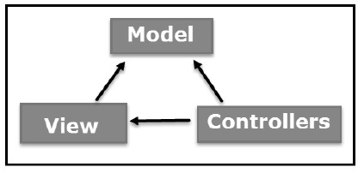

Figure : MVC pattern

Advantages of MVC:

• It helps in the rapid development of an application. Here one of the programmers can work on view while the other one can work on controller.

• There is a minimal chance of code duplication in this method as it separates data and business logic from the display

• It supports asynchronous technique which helps to develop an application that loads very fast.

• Modification does not affect the entire model because model part does not depend on the views part.

Disadvantages of MVC:

• It increases the complexity of the application.

• Multiple programmers are needed.

• Developers must have knowledge on multiple technologies.

• There is shortage of efficiency of data access in view.

The tools that I will use in this project are:

|  |  |
| --- | --- |
| Programming Paradigm | Object Oriented |
| Server Solution Stack | XAMPP |
| Modelling Tool | Visual Paradigm |
| Framework | Laravel |
| Programming language | PHP |
| Database | MySQL |

## Architecture:

For this project I have followed 3-tier architecture pattern. **Three-tier architecture** typically comprise a presentation tier, a business or data access tier, and a data tier. Three layers in the three-tier architecture are as follows:

**1) Client layer**  
 **2) Business layer**  
 **3) Data layer**

**1) Client layer:**

It is also called as *Presentation layer* which contains UI part of our application. This layer is used for the design purpose where data is presented to the user or input is taken from the user. For example, designing registration form which contains text box, label, button etc.

**2) Business layer:**

In this layer all business logic written like validation of data, calculations, data insertion etc. This acts as a interface between Client layer and Data Access Layer. This layer is also called the intermediary layer helps to make communication faster between client and data layer.

**3) Data layer:**

In this layer actual database is comes in the picture. Data Access Layer contains methods to connect with database and to perform insert, update, delete, get data from database based on our input data.

This architecture has few advantages and disadvantages which includes:

Advantages:

1. High performance, lightweight persistent objects
2. Scalability – Each tier can scale horizontally
3. Performance – Because the Presentation tier can cache requests, network utilization is minimized, and the load is reduced on the Application and Data tiers.
4. High degree of flexibility in deployment platform and configuration
5. Better Re-use
6. Improve Data Integrity
7. Improved Security – Client is not direct access to database.
8. Easy to maintain and modification is bit easy, won’t affect other modules
9. In three tier architecture application performance is good.

Disadvantages:

1. Increase Complexity/Effort

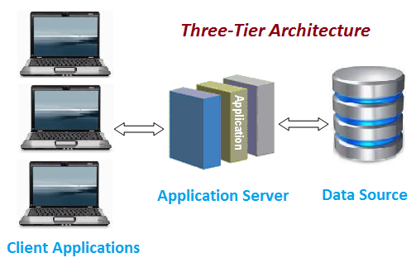

Figure : Three-tier architecture

This architecture makes the program much easier to develop.

# Chapter 4: Project Planning:

## WBS:

A work breakdown structure (WBS) is a key project deliverable that organizes the team's work into manageable sections. The Project Management Body of Knowledge (PMBOK) defines the work breakdown structure as a "deliverable oriented hierarchical decomposition of the work to be executed by the project team." The work breakdown structure visually defines the scope into manageable chunks that a project team can understand, as each level of the work breakdown structure provides further definition and detail. The plan that I have followed for the project is given below:

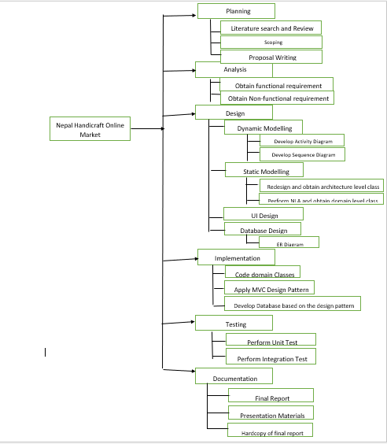

Figure : WBS figure 1

|  |  |  |
| --- | --- | --- |
| WBS | Task Name | Estimate Time (Days) |
| 0. | Project-Nepal Handicraft Online Market | 109 |
| 1. | **Planning** | **15** |
| 1.1. | Literature Search and Review | 3 |
| 1.2. | Scoping | 2 |
| 1.3. | Proposal Writing | 10 |
| 2. | **Analysis** | **29** |
| 2.1. | Obtain Functional Requirement | 15 |
| 2.2. | Obtain Non-functional Requirement | 14 |
| 3. | **Design** | **26** |
| 3.1. | Dynamic Modelling | 6 |
| 3.2. | Static Modelling | 5 |
| 3.3. | UI Design | 11 |
| 3.4. | Database Design | 4 |
| 4. | **Implementation** | **21** |
| 4.1. | Code Domain Classes | 6 |
| 4.2. | Apply MVC pattern | 10 |
| 4.3. | Develop Database based on Design Pattern | 5 |
| 5. | **Testing** | **7** |
| 5.1. | Perform Unit Testing | 4 |
| 5.2. | Perform Integration Testing | 3 |
| 6. | **Documentation** | **11** |
| 6.1 | Final Report | 5 |
| 6.2. | Presentation Materials | 4 |
| 6.3. | Hardcopy of final report | 2 |

For this project, I have taken 109 days where for planning I have allocated 15 days, for analysis 29 days, for design 26 days, for implementation 21 days, for testing 7 days and for documentation 11 days.

## Milestone:

The milestone for this project is briefly given in the table below with the start date and with their corresponding deadlines.

|  |  |  |
| --- | --- | --- |
| Topic | Start Date | Deadline |
| **Proposal** | **26th March 2019** | **9th April 2019** |
| Literature Search and Review | 3/26/2019 | 3/28/2019 |
| Scoping | 3/29/2019 | 3/30/2019 |
| Proposal Writing | 3/31/2019 | 4/9/2019 |
| **Analysis** | **10th April 2019** | **8th May 2019** |
| Obtain Functional Requirement | 4/10/2019 | 4/24/2019 |
| Obtain Non-functional Requirement | 4/25/2019 | 5/8/2019 |
| **Design** | **9th May 2019** | **3rd June 2019** |
| Dynamic Modelling | 5/9/2019 | 5/14/2019 |
| Static Modelling | 5/15/2019 | 5/19/2019 |
| UI Design | 5/20/2019 | 5/30/2019 |
| Database Design | 5/31/2019 | 6/3/2019 |
| **Implementation (Coding)** | **4th June 2019** | **24th June 2019** |
| Code Domain Classes | 6/4/2019 | 6/9/2019 |
| Apply MVC pattern | 6/10/2019 | 6/19/2019 |
| Develop Database based on Design Pattern | 6/20/2019 | 6/24/2019 |
| **Testing** | **25th June 2019** | **1st July 2019** |
| Perform Unit Testing | 6/24/2019 | 6/28/2019 |
| Perform Integration Testing | 6/29/2019 | 7/1/2019 |
| **Final Doc** | **2nd July 2019** | **12th July 2019** |
| Final Report | 7/2/2019 | 7/6/2019 |
| Presentation Materials | 7/7/2019 | 7/10/2019 |
| Hardcopy of final report | 7/11/2019 | 7/12/2019 |

## Gantt Chart:

A Gantt chart is a graphical depiction of a project schedule. It's is a type of bar chart that shows the start and finish dates of several elements of a project that include resources, milestones, tasks, and dependencies. Henry Gantt, an American mechanical engineer, designed the Gantt chart. This is a very effective way for planning and allocating time for different tasks of a project.

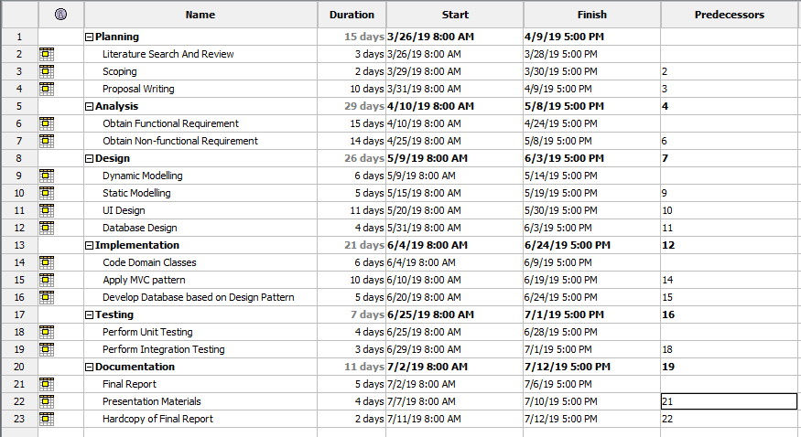

Figure : Project Schedule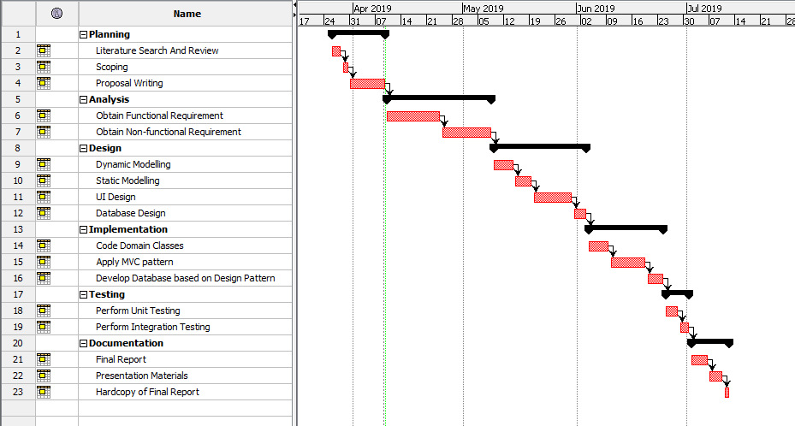Figure : Gantt Chart

# Chapter 5: Risk Management

**Risk management** is the identification, evaluation, and prioritization of risks (defined in ISO 31000 as *the effect of uncertainty on objectives*) followed by coordinated and economical application of resources to minimize, monitor, and control the probability or impact of unfortunate events or to maximize the realization of opportunities.

For the risk management its most to find the risks that can damage the system. The steps that we can follow for risk management are:

1. Identify risk
2. Access impact of risk
3. Alleviate critical risk
4. Control risk

We follow the following two table to calculate the impact of the risk.

|  |  |
| --- | --- |
| Likelihood | Value |
| Low | 1 |
| Medium | 2 |
| High | 3 |

|  |  |
| --- | --- |
| Consequences | Value |
| Very Low | 1 |
| Low | 2 |
| Medium | 3 |
| High | 4 |
| Very high | 5 |

Taking this value, we can calculate the risk management as Impact = Likelihood x Consequences

The table containing the risk management is given below:

|  |  |  |  |  |  |  |
| --- | --- | --- | --- | --- | --- | --- |
| Risk Type | Risk | Likelihood | Consequences | Impact | Action type | Action |
| Non-Technical | Increasing the growth of the project which causes the project to go over the budget | 2 | 3 | 6 | Avoidance | Thorough planning of the requirement specification of the project |
| Natural Disaster | 2 | 4 | 8 | Contingency | Regular backup of data to prevent any data loss |
| Deadline Overruns | 2 | 4 | 8 | Contingency | Keeping tabs of the time so that the work will be completed before the deadline |
| Technical | Hardware failure | 2 | 3 | 6 | Avoidance | Proper maintenance of hardware to prevent any issues |
| Hard disk failure | 3 | 5 | 15 | Contingency | Cloning the hard disk before starting any project |
| Technical difficulty during design and implementation | 2 | 3 | 6 | Deflection | Getting advice from superior and other faculty member to prevent any difficulty. |

I have listed out solution for the risk that have high impacts such as

1. Following the proper procedure to minimize the risks.
2. Proper backup of data to prevent data loss
3. Following the timetable in a proper order to finish the project in time.

# Chapter 6: Configuration Management

The project is based on the SDLC or waterfall model so it has directory that is based on this model. Each phase has its own folder and contain its own files. The final project directory contains the following folder in it:

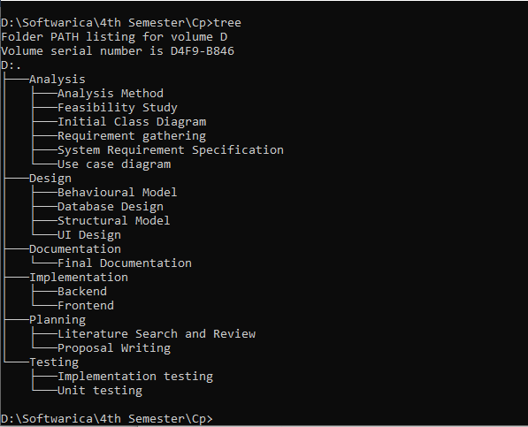

Figure : Directory Structure for Project

Analysis folder contain other folder such as analysis method, feasibility study, initial class diagram, requirement gathering, system requirement specification and use case diagram. Design folder contain folder such as behavioral model, structural model and UI design. Implementation folder contain folder such as backend and frontend. Testing folder contains folder such as implementation testing and unit testing. Planning folder contains folder such as literature search and review and proposal writing. Documentation folder contain final documentation.

# Conclusion

Nepal Handicraft Online Market is an online market that deals with the handicraft product that are found in Nepal where there is facility like online transaction, product info, etc. This system is made so that there will be a constant market place for the product that are made in Nepal. For this system I have followed Waterfall model as main methodology, MVC as design pattern and three-tier architecture. The planning to complete this project is done with thorough study of the various work that I need to do and without going over the deadline. For this project I have use Laravel as framework and php as its main programming language. This project contains the necessary detail for the market system allowing people to sell their goods. For the configuration management, since I have followed the SDLC methodology the folder is made as per the phases contain in the methodology.

# References and Bibliography

1. Bauder, B., Hochgreve, T., & Marquarth, A. (2001). *PHP.* Düsseldorf: Data-Becker.
2. Brewer, J. L., & Dittman, K. C. (2013). *Methods of IT project management*. West Lafayette, IN: Purdue University Press.
3. Rahman, S. (2016). *Design pattern: Obligation link design pattern*. Beaumont, TX: Lamar University.
4. Siegel, J. G., & Shim, J. K. (2003). *The managers handbook of client/server computing in business and finance*. Mason, OH: Thomson/South-Western.
5. Metsker, S. J. (2002). *Design patterns Java workbook*. Boston: Addison-Wesley.